Game Design Document

Fill up the following document

1. Write the title of your project.

Rocket game

1. What is the goal of the game?

Shoot as many stars as possible

1. Write a brief story of your game.

Your rocketship is in space. Move your rocketship around to avoid the incoming asteroids (obstacles, and try shoot the stars to gain points.

When you hit an asteroid, you die and the game ends.

1. Which are the playing characters of this game?

* Playing characters are the ones who respond to the user based on the input from the user.
* Cars, monkeys, dinos, wizards, etc., are the playing characters in the game.

|  |  |  |
| --- | --- | --- |
| Number | Character Name | What can this character do? |
| 1 | Main rocketship | Move with arrow keys + shoot |
| 2 |  |  |
| 3 |  |  |
| 4 |  |  |
| 5 |  |  |
| 6 |  |  |
| 7 |  |  |
| 8 |  |  |

1. Which are the Non-Playing Characters of this game?

* Non-Playing characters are the ones that don't have an action or behavior when the user interacts with the game.
* Hurdles, stones, bananas, coins, etc., are non-playing characters in the game.

|  |  |  |
| --- | --- | --- |
| Number | Character Name | What can this character do? |
| 1 | Stars | Shot to earn points |
| 2 | Random asteroids | Obstacle |
| 3 |  |  |
| 4 |  |  |
| 5 |  |  |
| 6 |  |  |
| 7 |  |  |
| 8 |  |  |

Draw your imagination of this game. What does this game look like?

* Draw the game either on your computer or on paper.
* 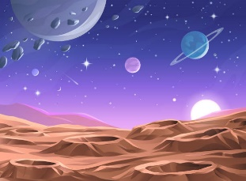Add images of the game scenes to show each of the playing and non-playing characters at least once.



How do you plan to make your game engaging?

Put a score system and avoid the asteroids (obstacles) so that you don’t die. Get as much points as possible before you die.